Rule Learning Subgroup Discovery
Code:
import numpy as np
import pandas as pd
import matplotlib.pyplot as plt
import seaborn as sns
from sklearn.datasets import load_iris

iris = load_iris(as_frame=True)
df = iris.frame
df['species'] = df['target'].map({0:'setosa', 1:'versicolor', 2: 'virginica'})
df.head()

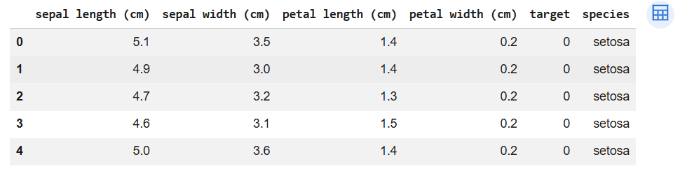

def discover_subgroup(data, condition, label_col = 'species'):
subgroup = data.query(condition)
return {
'Condition' : condition,
'Subgroup' : len(subgroup),
'Distribution' : subgroup[label_col].value_counts(normalize=True).to_dict(),
'Data' : subgroup,

}

rules = [
"`petal length (cm)` > 4",
"`sepal length (cm)` > 3",
"`petal width (cm)` > 4 and `petal width (cm)` > 1.5"
]

for res in results:
subgroup = res["Data"]
rule = res["Condition"]

fig, axes = plt.subplots(1, 2, figsize=(12, 4))
fig.suptitle(f"Subgroup for Rule: {rule}", fontsize=16, fontweight = "bold")

axes[0].scatter(df["petal length (cm)"], df["petal width (cm)"], label = 'AllData')
for species, color in zip(['setosa', 'versicolor', 'virginica'], ['blue', 'green', 'red']):
subset = subgroup[subgroup["species"] == species]
axes[0].scatter(subset["petal length (cm)"], subset["petal width (cm)"], label = f"(species) ({len(subset)})", c=color)
axes[0].set_xlabel("Petal Length (cm)")
axes[0].set_ylabel("Petal Width (cm)")
axes[0].legend()
axes[0].set_title("Scatterplot of Subgroup")

counts = pd.Series(res["Distribution"])
counts.plot(kind = 'bar', ax = axes[1], color = ['blue', 'green', 'red'], alpha = 0.7)
axes[1].set_xlabel("Species")
axes[1].set_ylabel("Count")
axes[1].set_title("Distribution of Species in Subgroup")
plt.tight_layout()
plt.show()

Output:
